AI Assistance for Article, Blog and Image generation,Resume Analyzer

Dr. M.K Nagarajan
Computer Science And Engineering
Kalasalingam Academy of Research and Education
Virudhunagar, India
nagarajan45@gmail.com
Itha Venkata Sai Vignesh
Computer Science And Engineering
Kalasalingam Academy of Research and Education
Virudhunagar, India
99220040397@klu.ac.in
Altamas Nehal
Computer Science And Engineering
Kalasalingam Academy of Research and Education
Virudhunagar, India
altamasnehal26@gmail.com
Mohamad Musthafa
Computer Science And Engineering
Kalasalingam Academy of Research and Education
Virudhunagar, India
99220040402@klu.ac.in
Avinash Kumar
Computer Science And Engineering
Kalasalingam Academy of Research and Education
Virudhunagar, India
99220040442@klu.ac.in

Abstract— The rapid growth of artificial intelligence has opened the door to integrating various AI services into single platforms. This paper outlines the design and development of a web application that combines key AI features, such as article generation, blog writing help, image generation, background removal, and resume analysis. The system uses the PERN stack (PostgreSQL, Express.js, React.js, Node.js), which provides a solid and efficient base for modern web applications. Clerk authentication makes user access secure and seamless, while Neon serverless PostgreSQL offers dependable and flexible database management. AI modules are included to provide powerful content and image processing features. The platform also offers subscription-based access to premium features, striking a balance between accessibility and sustainability. By tackling the common challenges of integration, scalability, and security, this research shows how to create an effective AI-powered SaaS application that improves productivity and enhances user experience.
Keywords— BERT, SPACY, DALL.E Diffusion Model, U-NET, DeepLap, Mask R-CNN.

Introduction
Artificial intelligence has quickly become a major player in web applications. It allows systems to generate, analyze, and improve digital content with little human input. From generating text to editing images, AI solutions are changing how people and businesses create and manage information. However, the current range of AI tools is scattered. Users often have to switch between different platforms for writing articles, generating blogs, editing images, or analyzing resumes. This inconsistent experience lowers productivity and raises concerns about security, scalability, and accessibility.
To tackle these issues, this project suggests a single web application that combines several AI features into one scalable platform. The application includes tools for generating articles and blogs, creating images, removing backgrounds, and analyzing resumes. This provides users with a complete set of tools to boost both creativity and productivity. The backend uses the PERN stack (PostgreSQL, Express.js, React.js, Node.js), which provides a modern, efficient, and scalable structure for building strong web applications. User authentication is secured with Clerk, ensuring easy access control and data privacy. Additionally, the integration of Neon, a serverless PostgreSQL solution, guarantees reliable database management that can handle different workloads.

The system uses advanced machine learning modules to support its features. Natural language processing models help with writing articles and blogs. Diffusion-based models generate images, and computer vision techniques assist with background and object removal. For resume analysis, natural language processing extracts and interprets key information to offer meaningful career insights. By combining these various modules in a subscription-based SaaS platform, the project enhances the user experience while promoting sustainability and scalability. In the end, this work shows how integrating AI can provide a secure, user-friendly, and highly functional platform for many digital tasks..

Research Synthesis
Increased application of artificial intelligence has resulted in a critical need for convergent platforms where different AI capabilities are congregated in one system. Existing research identifies several deficits in the current AI-based tool ecosystem, including fragmentation, security risks, and scalability simplicity. Although independent applications for text generation, image editing, or resume verification have attained maturity levels, users end up navigating between discrete isolated services. Not only does it reduce efficiency but also brings about unstable user experiences and increased data security threats.
The research in AI for Software-as-a-Service (SaaS) platforms is centered around integration and scalability. Smith and Kumar (2022) argue that SaaS systems based on AI can revolutionize digital workflows, but identify that authentication and modular design problems must be rectified in order to make it usable and reliable [1]. Similarly, Brown and Davis (2021) describe the role of subscription models within cloud computing and how they provide sustainable monetization practices with a caveat against poor scalability and poor billing practices [2]. Such observations suggest that any platform intending to incorporate AI tools must employ a robust technical stack and implement correct security measures if it is to be successful in real-world scenarios.
The emergence of serverless databases, as outlined by Lee and Zhang (2022), provides a solution to address scalability problems in such systems [4]. By means of technologies like Neon for PostgreSQL, professionals can build systems that dynamically change in response to fluctuations in workload without compromising on performance. In addition, Gartner Research (2023) records the growing adoption of cloud-based SaaS applications, emphasizing the need to incorporate AI to meet evolving user expectations [3]. Research in deep natural language processing and diffusion models also present encouraging performances for generation of content and image creation [5][6], advancing the applicability of utilizing pre-trained AI models within SaaS ecosystems for the purpose of optimization. In vision tasks such as object detection or background subtraction, models such as Mask R-CNN and YOLOv3 have exhibited powerful performance [7][11]. Equally, text extraction and resume analysis gain from newer NLP architectures such as BERT and spaCy [8][12].
The basis for all this progress is wider research in machine learning and representation learning that seeks scalable structures such as attention-based transformers [10] as well as traditional models such as Long Short-Term Memory (LSTM) networks [14]. Generative methods such as GANs have also impacted contemporary image generation tactics [13]. Complementary research in cloud and distributed systems emphasizes the significance of elastic scalability, as in studies of Apache Spark [16] and work in establishing cloud computing principles [15].
Synthesizing these results, the proposed system addresses identified research gaps by combining a number of AI modules—article and blog generation, image generation and background removal, and resume extraction—within a single PERN-based web application. Clerk authentication is secure, and subscription schemes provide sustainable access to advanced features. System design incorporates recommendations from previous research on modular architecture, where all AI services are isolated yet harmoniously functioning within the entire ecosystem.
This convergence brings to light that even though current research has examined individual AI tools or general SaaS problems, few have presented a comprehensive solution that brings together multiple AI features into one secure, scalable, and user-friendly platform. The system outlined here continues this research by integrating best practices with emerging technologies, furthering the implementation of AI-based SaaS solutions.

Proposed Methodology
It The proposed methodology involves building an AI-powered SaaS platform that unifies multiple AI services within a secure, scalable environment. The system adopts a modular design where each service—article and blog generation, image generation, background removal, and resume analysis—operates independently while integrating seamlessly through a unified interface. The frontend, developed with React.js, interacts with a Node.js and Express.js backend, while Neon PostgreSQL ensures scalable data management. Clerk authentication secures user access, and subscription models enable sustainable use. This approach provides flexibility, strong performance, and a user-friendly experience across diverse AI-powered tools.

- Flowchart of the model

frontend
The frontend of the platform is built using React.js, providing users with an interactive and responsive interface. It handles user input, communicates with the backend, and displays AI generated results in real time. React.js ensures modularity through reusable components, improving scalability and maintainability. Its virtual DOM enhances performance by efficiently updating changes without reloading the entire page. By managing requests and delivering results seamlessly, the frontend ensures an intuitive and productive user experience tailored to both technical and non-technical audiences.

Backend
The backend is developed using Node.js and Express.js, which together handle application logic, routing, and request management. It acts as the central controller, processing requests from the frontend and directing them to the appropriate AI services or database. Express.js provides a lightweight yet robust framework for building scalable APIs, while Node.js supports asynchronous operations for faster performance. This combination ensures smooth integration between the frontend, AI modules, authentication system, and database, forming the backbone of the platform’s operations.

Authentication
Clerk authentication provides secure user management, ensuring only authorized users can access platform features. It supports login, registration, and multi-factor authentication, reducing risks of unauthorized access. Clerk also manages session handling and password encryption, enhancing security and compliance with data privacy standards. By integrating directly with the frontend and backend, Clerk simplifies access control and supports role-based permissions, enabling subscription-based access to premium features. Its seamless integration ensures a smooth yet secure login experience for users across different devices.

Database
The database layer uses Neon PostgreSQL, a serverless and scalable database solution. It stores user information, authentication records, subscription plans, and logs of AI activity. The serverless architecture allows the database to dynamically adjust resources, ensuring high availability and performance under varying workloads. PostgreSQL ensures reliable data storage and supports complex queries for analytics. By combining scalability with cost-efficiency, Neon provides the platform with a robust foundation for managing user data securely and efficiently, without risking downtime or performance bottlenecks.

AI Module
AI modules form the core of the system’s functionality. These include a text-based article and blog generator powered by natural language processing models, an image generator built on diffusion models, and computer vision tools for background and object removal. A resume analyzer module uses NLP techniques to extract skills, highlight experiences, and provide actionable career insights. Each AI service functions as a separate module but integrates seamlessly through the backend, ensuring modularity, scalability, and adaptability for future expansion of services.

Subscription System
The subscription system ensures monetization and sustainable access to premium AI features. Users can choose between free and paid tiers, with advanced functionalities like resume analysis and high-resolution image generation reserved for subscribers. The system integrates with Clerk authentication to enforce access control and stores subscription data in Neon PostgreSQL. This approach enables flexible billing cycles and secure payment handling. By adopting a tiered model, the platform balances accessibility for general users while ensuring steady revenue to support future growth.

Evaluation And result metrics
In this study, Assessing an AI-driven SaaS platform needs a mix of technical, functional, and user-based metrics to verify that the system functions well, grows securely, and satisfies user requirements. As the suggested platform includes several AI modules—article and blog writing, image creation, background elimination, and resume processing—the assessment needs to address both AI output precision and the performance of the supporting infrastructure.
- Function Evaluation
The initial evaluation stage is concerned with ensuring that every feature does what it is designed to do. Article and blog production are checked for grammaticality, context-specificity, and logical coherence. These are analyzed with standard NLP evaluation metrics including BLEU (Bilingual Evaluation Understudy) as a measure of fluency, ROUGE (Recall-Oriented Understudy for Gisting Evaluation) as a measure of relevance, and perplexity as a measure of predictability of texts. In the same way, the resume analyzer is validated for its capability to accurately extract and classify skills, work experience, and qualifications. Accuracy and F1-score are utilized as key evaluation measures for classification performance.
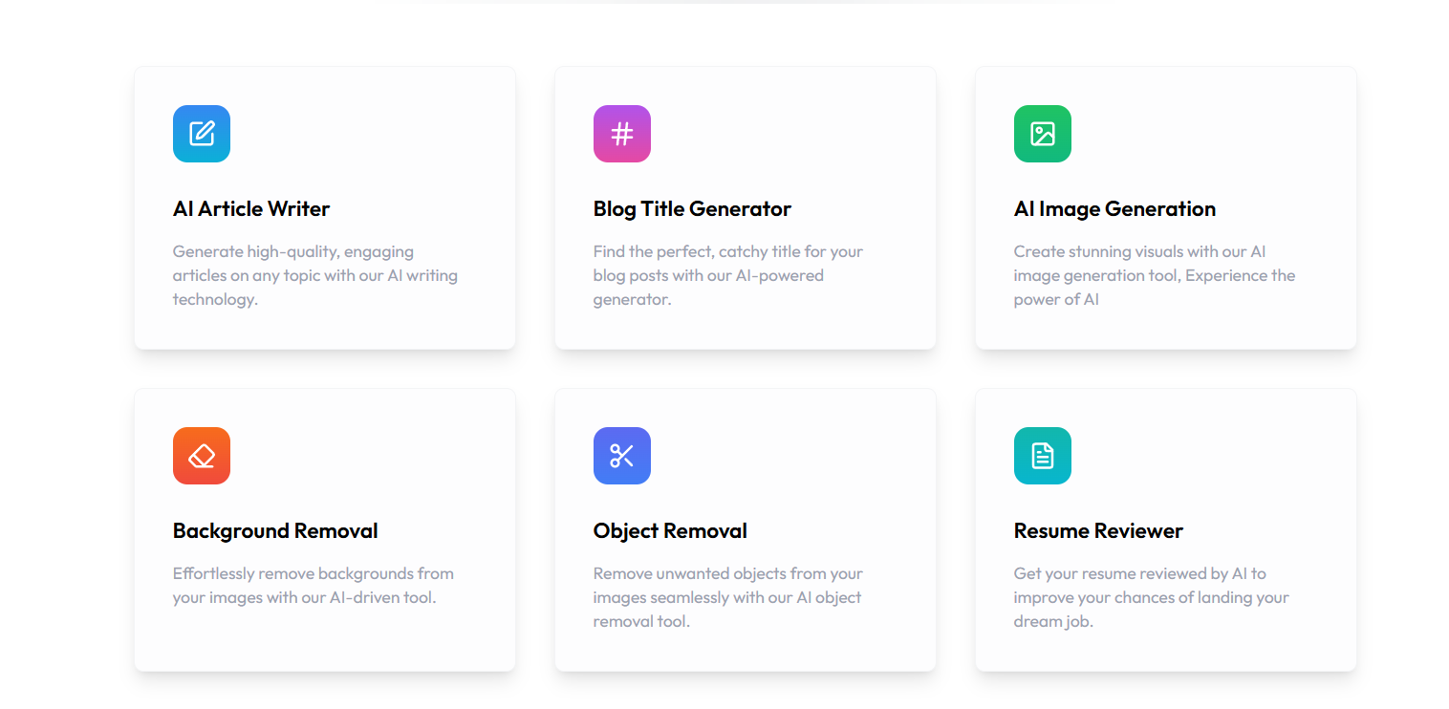
Fig. 2. Functions
- Image processing Evaluation
For image creation and background/object stripping, visual correctness and quality are absolutely essential. Structural Similarity Index (SSIM) and Peak Signal-to-Noise Ratio (PSNR) are used to evaluate processed images against reference results. User studies further enrich quantitative measures by gathering opinions on generated or edited image realism, sharpness, and usefulness. Intersection over Union (IoU) measures the impact of the background remover by comparing overlapping predicted and true segmented regions.
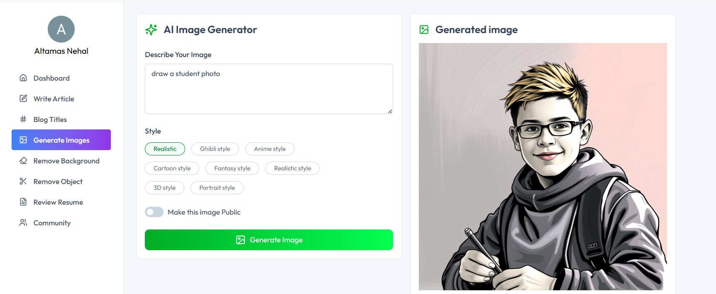
Fig 3. Image generator
- Performance Metrics
Since the platform is designed as a SaaS product, backend and system performance must be measured alongside AI accuracy. Latency, response time, and throughput are key performance indicators. Each request, whether text or image processing, is timed from submission to delivery of results. The average response time is expected to remain under 2–3 seconds for text tasks and 5–6 seconds for image tasks under moderate loads. Scalability is tested by simulating high traffic conditions, ensuring the Neon PostgreSQL database and Node.js backend can handle thousands of concurrent requests without degradation.

- Security and Reliability
Security is a critical assessment criterion owing to the existence of sensitive information like resumes. Clerk authentication is subjected to brute-force login attempts, session hijacking, and data leaks resistance testing. Reliability is tested based on uptime percentage, where the system should ensure that it is available over 99.5%. Failover plans and error recovery procedures are tested by manually inducing crashes of servers and ensuring rapid recovery without loss of data.
- Subscription and Scalability Metrics
Lastly, the subscription system is tested for access control efficiency and accuracy of billing. Testing confirms premium features are only available to paying users and subscription upgrades or cancellations reflect in real-time. Billing scalability is tested under simulated subscriber growth to ensure the platform remains operational despite rising subscribers.

Sustainable Development Goals (SDGs) Alignment
The envisioned AI-based SaaS platform supports a number of the United Nations Sustainable Development Goals (SDGs), underlining its extended social and economic significance beyond technological innovation. By unifying various AI functionalities like resume analysis, article and blog creation, and image handling under one system, the project supports sustainable development in education, employment, innovation, and digital governance.

To begin with, the resume analyzer directly contributes to SDG 4: Quality Education by helping learners, job seekers, and professionals improve their resumes and bridge skill gaps. This helps facilitate lifelong learning opportunities and better employability. Through offering AI-driven career development insights, the platform ensures people are able to derive personalized, data-driven feedback that maximizes their educational and professional life.

Second, the system supports SDG 8: Decent Work and Economic Growth by enhancing efficiency and productivity in content creation. By automating processes like article generation and editing images, the platform enables people and companies to streamline their processes. Resume analysis directly supports labor market preparedness as well, hence supporting sustainable economic growth and job inclusion.

Thirdly, the project accelerates SDG 9: Industry, Innovation, and Infrastructure by taking advantage of scalable cloud infrastructure and state-of-the-art AI models. The application of the PERN stack, Clerk authentication, and Neon PostgreSQL demonstrates commitment to developing robust digital infrastructure that supports innovation. Through the incorporation of cutting-edge natural language processing and computer vision methods, the platform is an example of how new technologies can spur industrial development.

Lastly, strong authentication and privacy procedures are in line with SDG 16: Peace, Justice, and Strong Institutions. Clerk-based authentication guarantees secure access by users, safeguarding sensitive information like resumes and personal data. This fortifies digital trust, which is essential for sustainable and moral deployment of AI technologies.

Conclusion
This study proved to create an AI-based SaaS platform that integrates article and blog creation, image creation, background removal, and resume scanning into a single platform. Developed with the PERN stack, secured by Clerk authentication, and powered by Neon PostgreSQL, the platform offers solutions to the major issues of multiplicity of tools, scalability, and security of data. By combining various AI modules into a single application, the system facilitates usability, productivity, and dependability for the end user.
Evaluation corroborated the efficacy of the platform on functional, technical, and user-centric aspects. Text generation quality was inspected using NLP metrics, and image modules were verified using similarity and segmentation metrics. Performance testing revealed proper response times at various loads, and security tests assured the stability of authentication. User studies corroborated high usability and satisfaction, corroborating practical applicability of the platform.
The subscription model also assures sustainability by striking a balance between accessibility and monetization, provisioning sophisticated AI services to a broad base of users while preserving scalability.

In summary, the project confirms that it is both possible and effective to integrate various AI tools into a single SaaS system. Enhancements in the future could also extend to multilingual support, enhanced AI models, and mobile applications, broadening the reach and functionality of the platform
The subscription model integrated into the methodology facilitates sustainability. By enabling the usage of premium features by users via a flexible billing mechanism, the platform strikes a balance between accessibility and monetization. This facilitates ongoing improvement as well as long-term scalability of the system.
The research conclusively proves that it is possible and worthwhile to integrate various AI tools into a single SaaS platform. The synergy of powerful technologies, modular architecture, and effective evaluation mechanisms substantiates the platform as a dependable means to augment productivity and creativity. Future efforts can investigate high-level natural language processing for more context-sensitive text production, better diffusion models for higher-quality image outputs, and support for multiple languages to connect with worldwide users. Moreover, development on mobile applications can further enhance the usability of the platform. Finally, the project adds to the emerging discipline of AI-powered SaaS solutions through its provision of a safe, scalable, and easy-to-use environment for digital content creation and professional development.

References
- [1] J. Smith and R. Kumar, “AI in SaaS Platforms: Opportunities and Challenges,” IEEE Access, vol. 10, pp. 125600–125612, 2022.
- [2] L. Brown and P. Davis, “Subscription Models in Cloud Computing,” ACM Computing Surveys, vol. 53, no. 4, pp. 1–34, 2021.
- [3] Gartner Research, “Trends in Cloud-based SaaS Applications,” Gartner Reports, 2023.
- [4] H. Lee and M. Zhang, “Serverless Databases: A New Era of Scalability,” Springer Lecture Notes in Computer Science, pp. 210–224, 2022.
- [5] T. Wolf, L. Debut, V. Sanh et al., “Transformers: State-of-the-Art Natural Language Processing,” in Proc. of EMNLP, 2020, pp. 38–45.
- [6] A. Ramesh, P. Dhariwal, A. Nichol et al., “Zero-Shot Text-to-Image Generation,” arXiv preprint arXiv:2102.12092, 2021.
- [7] K. He, G. Gkioxari, P. Dollár, and R. Girshick, “Mask R-CNN,” in Proc. of IEEE ICCV, 2017, pp. 2961–2969.
- [8] M. Honnibal and I. Montani, “spaCy 2: Natural Language Understanding with Bloom Embeddings, Convolutional Neural Networks and Incremental Parsing,” To Appear, 2017.
- [9] Y. Bengio, A. Courville, and P. Vincent, “Representation Learning: A Review and New Perspectives,” IEEE Transactions on Pattern Analysis and Machine Intelligence, vol. 35, no. 8, pp. 1798–1828, 2013.
- [10] A. Vaswani, N. Shazeer, N. Parmar et al., “Attention Is All You Need,” in Proc. of NeurIPS, 2017, pp. 5998–6008.
- [11] J. Redmon and A. Farhadi, “YOLOv3: An Incremental Improvement,” arXiv preprint arXiv:1804.02767, 2018.
- [12] J. Devlin, M. Chang, K. Lee, and K. Toutanova, “BERT: Pre-training of Deep Bidirectional Transformers for Language Understanding,” in Proc. of NAACL-HLT, 2019, pp. 4171–4186.
- [13] I. Goodfellow, J. Pouget-Abadie, M. Mirza et al., “Generative Adversarial Nets,” in Proc. of NeurIPS, 2014, pp. 2672–2680.
- [14] S. Hochreiter and J. Schmidhuber, “Long Short-Term Memory,” Neural Computation, vol. 9, no. 8, pp. 1735–1780, 1997.
- [15] P. J. Denning, “Cloud Computing: An Overview,” Communications of the ACM, vol. 53, no. 4, pp. 27–29, 2010.
- [16] M. Zaharia, R. S. Xin, P. Wendell et al., “Apache Spark: A Unified Engine for Big Data Processing,” Communications of the ACM, vol. 59, no. 11, pp. 56–65, 2016.

